**A**

**Synopsis on**

**“ONLINE E-FARMING STORE WEBSITE”**

**Submitted in partial fulfillment of the requirements**

**of the degree of**

**Bachelor Of Engineering**

**By**

**Ms. Tejaswini Lingayat (39)**

**MS. Kranti Palekar(45)**

**Under the guidance of**

**Prof. Amol Gaikwad**

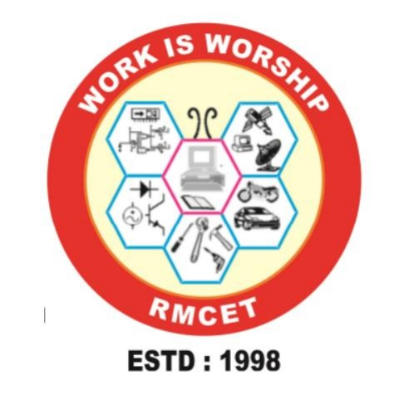

**DEPARTMENT OF COMPUTER ENGINEERING**

**RAJENDRA MANE COLLEGE OF ENGINEERING AND TECHNOLOGY AMBAV (Devrukh) – 415804**

**UNIVERSITY OF MUMBAI 2024-2025**

**Abstract**

The Online E-Farming Store Website project is dedicated to creating an efficient and user-friendly platform specifically designed for the buying and selling of used farming products. Utilizing Java Server Pages (JSP) technology, this website will enable farmers to list their pre-owned equipment, tools, and other agricultural products, providing detailed descriptions, images, and pricing information. The platform will ensure secure transactions and offer features such as real-time inventory updates, order tracking, and robust customer support. By directly connecting farmers, the website aims to facilitate a transparent and cost-effective marketplace, allowing sellers to reach a wider audience and buyers to find affordable, quality farming equipment. Additionally, the platform will include resources on best practices for maintaining and using second-hand equipment, thereby promoting sustainability and resource efficiency within the farming community. This project endeavours to support farmers by reducing costs and enhancing access to essential farming tools, contributing to a more sustainable and economically viable agricultural sector.

**1.Introduction**

The Online E-Farming Store Website project aims to revolutionize the agricultural marketplace by leveraging the power of Java Server Pages (JSP) technology to create a robust platform for buying and selling farming products. Designed specifically for farmers, this website provides a user-friendly interface where they can list and sell their used equipment, tools, and other agricultural products directly to other farmers or interested buyers. This platform addresses the challenges faced by farmers in accessing affordable, quality farming equipment and tools. Traditional markets often involve multiple intermediaries, resulting in increased costs and reduced profitability for farmers. By facilitating direct transactions, the Online E-Farming Store eliminates the need for middlemen, thereby ensuring that farmers can buy and sell products at fair prices. The website will feature secure payment gateways, real-time order tracking, and comprehensive customer support to enhance the user experience. It will also include educational resources on maintaining and utilizing second-hand equipment, promoting sustainable practices within the farming community.

**2. Problem Statement**

Farmers often face significant challenges in accessing affordable and quality farming equipment and tools, which are essential for efficient and productive agricultural practices. Traditional marketplaces for these products involve multiple intermediaries, leading to increased costs and decreased profitability for farmers. Additionally, there is a lack of dedicated platforms that facilitate the buying and selling of used farming equipment, which could be a cost-effective solution for many farmers.

**3. Objectives**

1.**Eliminate Intermediaries:** Create a direct marketplace that connects farmers, reducing reliance on middlemen and thereby decreasing costs and increasing profitability for both sellers and buyers.

2 **Enhance Accessibility:** Provide a centralized, easily navigable platform where farmers can list and discover a wide range of used farming equipment, ensuring broader access to affordable and quality products.

3 **Ensure Secure Transactions:** Integrate secure payment gateways and transaction mechanisms to protect users' financial information and ensure safe, reliable exchanges.

4 **Improve Transparency:** Offer detailed product listings with descriptions, images, pricing, and availability to help buyers make informed purchasing decisions.

5 **Support Real-Time Operations:** Implement real-time inventory management and order tracking to streamline the buying and selling process, enhancing overall efficiency.

**4. Outline of proposed word**

.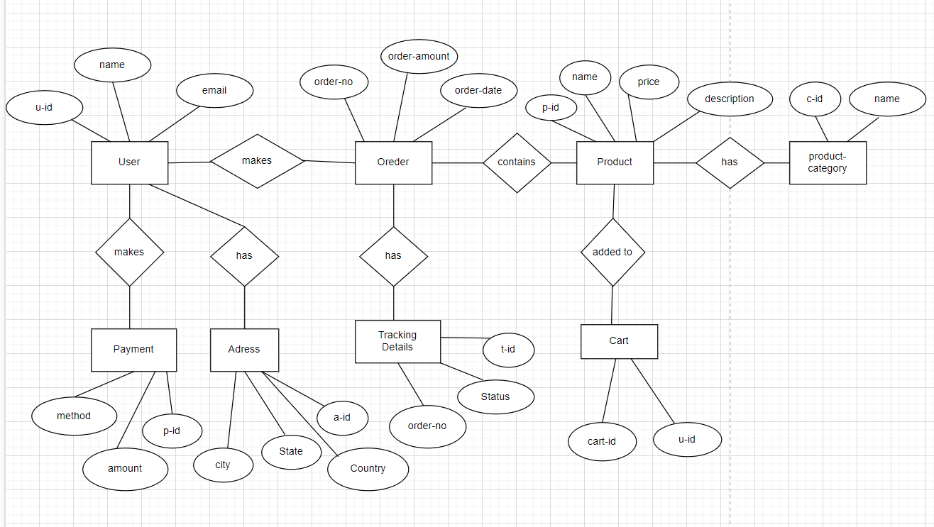

1. **System Requirements**

Software Requirements:

* Frontend: HTML, CSS
* Backend: Java
* Database: MySQL

Hardware Requirements:

* Processor: Pentium IV 2.7
* RAM: 1GB (minimum)
* Hard Disk: 532Mb